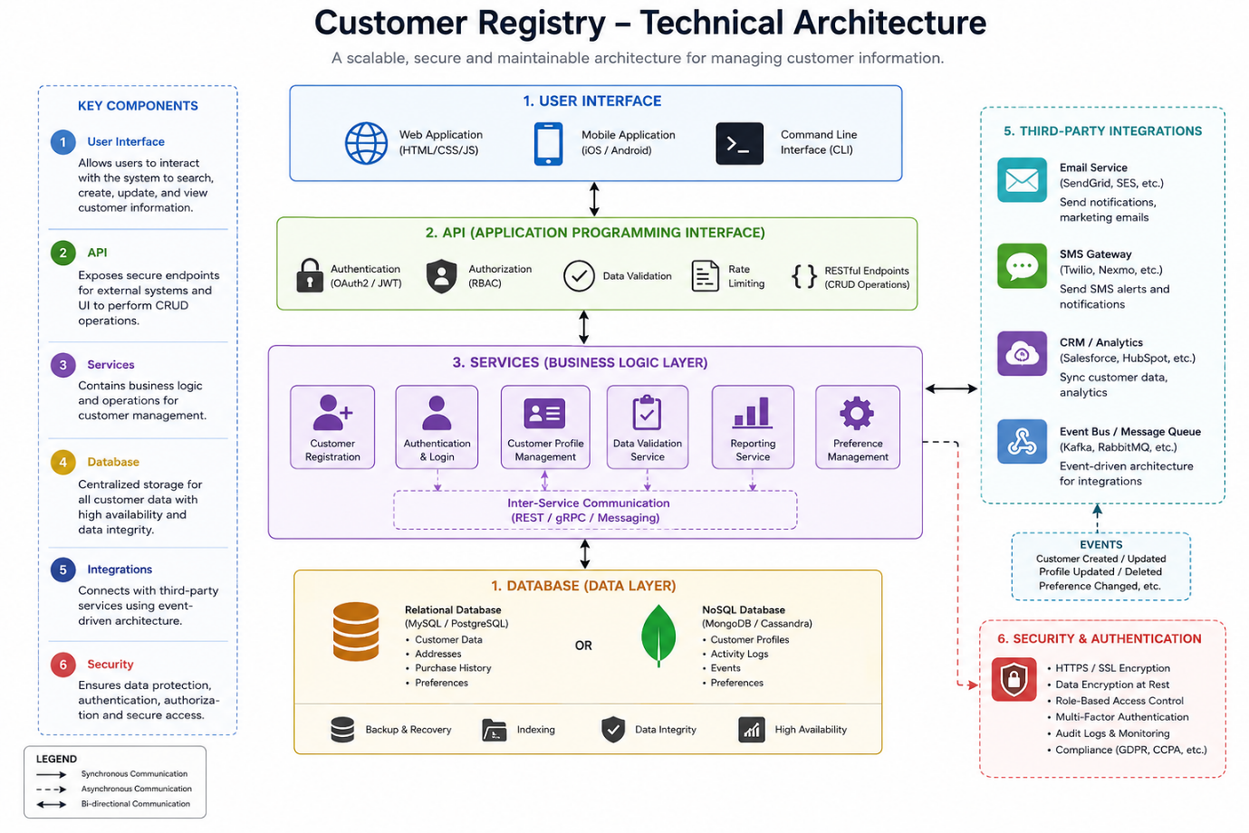Technical Architecture
The Customer Registry System is designed to store, manage, and maintain customer information efficiently. It provides a centralized platform where customer details can be securely stored, updated, searched, and managed. The system consists of several components that work together to ensure smooth operation and secure data management.
Database
The database is the central repository for storing customer information. It contains details such as customer ID, name, contact information, address, email, and other relevant records. The project can use MySQL, PostgreSQL, or MongoDB depending on the system requirements.

Backend
The backend is responsible for handling all business logic and communication between the user interface and the database. It processes user requests, validates data, performs CRUD (Create, Read, Update, Delete) operations, and returns the required information. The backend can be developed using Python, Java, Node.js, or other server-side technologies.

API (Application Programming Interface)
The API enables communication between the frontend and backend. It provides endpoints for customer registration, updating customer information, retrieving customer records, deleting customer data, and searching customers. The API also handles authentication and data validation.

Services
The system includes several services that perform different business operations, such as:
- Customer Registration
- Customer Login
- Customer Profile Management
- Customer Search
- Data Validation
- Report Generation
These services communicate with the database and API to complete user requests.

User Interface
The user interface provides an easy-to-use platform where users can interact with the system. It allows users to:
- Register new customers
- View customer details
- Update customer information
- Delete customer records
- Search customers
- Generate reports
The frontend can be developed using HTML, CSS, JavaScript, React, or Angular.

Integration with Third-Party Services
The Customer Registry System can integrate with external services such as:
- Email Services (Gmail, SMTP)
- SMS Gateway
- Payment Gateway (if required)
- Notification Services
- Cloud Storage
These integrations improve communication and customer management.

